**Perceptron Learning Lab**

Jason Liu

Period 5

**For boolean functions on n variables, a perceptron can learn:**

1. N=2:
   1. Learned: 14/16 = 87.5%
   2. 2 example functions and the learned weight vectors
      1. [0, 0 ,1]
      2. [0, 1, 1]
      3. Learned weight: [-0.5 -0.5 -1.5]
      4. Learned weight: [-0.5 -0.5 0.5]
2. N=3:
   1. Learned: 104/256= 40.625%
      1. [0, 0, 0, 1]
      2. [0, 0, 1, 1]
      3. Learned weight: [ 1.5 1.5 0.5 -0.5]
      4. Learned weight: [-1.5 -1.5 1.5 -0.5]
   2. 2 example functions and the learned weight vectors
3. N=4:
   1. Learned: ________/65536= ________%
   2. 2 example functions and the learned weight vectors

Create a training set and a testing set over 10 boolean inputs (x) where the function f(x) = majority. Use a training size of about 100 vectors. Plot the accuracy of a perceptron and of a decision tree, each on the testing set, for the target concept. The x-axis should be “training set size” and the y-axis “accuracy on test set”. Plot both functions on the same set of axes.

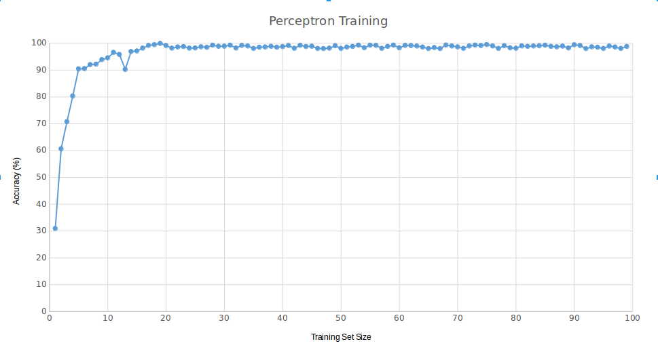For the perceptron: use as many epochs as you deem necessary. For both: do NOT test on the training data!